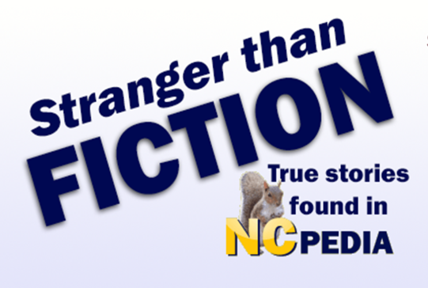
NCpedia.org
Test Your knowledge of North Carolina History Quiz
Warning: The History You Learn May Amaze You!

- What U.S. president served in both the Revolutionary War and the War of 1812?

- What North Carolina governor liked to eat possum?

- What legend is associated with Virginia Dare?

- What is North Carolina’s freakishly large state fossil?

- What is the “Thistle Dhu” (or “This’ll Do”) and what modern game is it associated with?

- Name two hoaxes associated with North Carolina history.

- Got facial hair? Name two North Carolinians who may have had “hairy” records.

- What year was the state marsupial established? And what is the state marsupial?

- What was the “Cool Pool”?

- North Carolina has a sort of “celebrity look-a-like”. Can you name who he was and the modern-day celebrity counterpart? (Hint: the North Carolinian was a poet.)

- Name four funny-sounding place names in North Carolina.

- What famous politician associated with North Carolina is also associated with a duel involving bacon?

- What well-known children’s TV celebrity lives in North Carolina?

- Name the North Carolinians who have been on “American Idol” in order of their appearance on the program.

- Name North Carolina’s legendary semi-mythical critter. (People reported seeing one in North Carolina in the 1930s.)

- Got lunch? What’s the name of North Carolina’s state carnivorous plant?

- Boo! Name three North Carolina events or places associated with ghosts.

- What mechanical creation came to Raleigh in 1840 and why was its name ironic?

- Who was the first woman to jump from a plane with a parachute in 1913?

